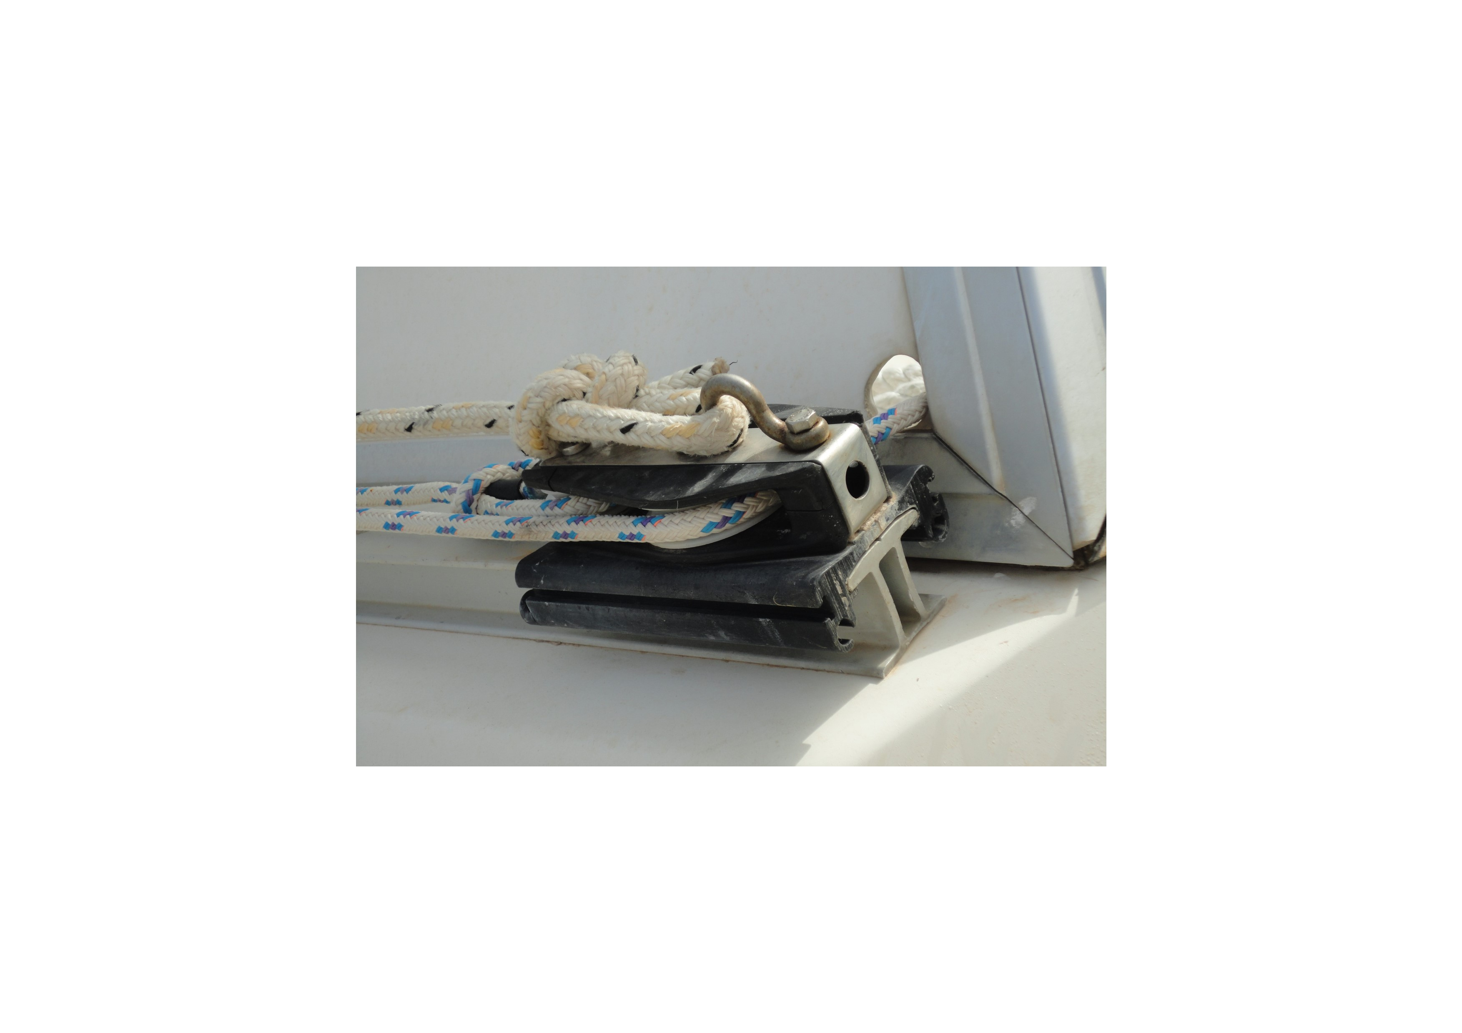

Port side end stop: track width 4cm, plastic moulded end stop width 6.5cm, track height 3.5cm. Two lower pulleys for traveller outhaul and return ropes. Larger top hoop fitting for end of traveller tension rope.

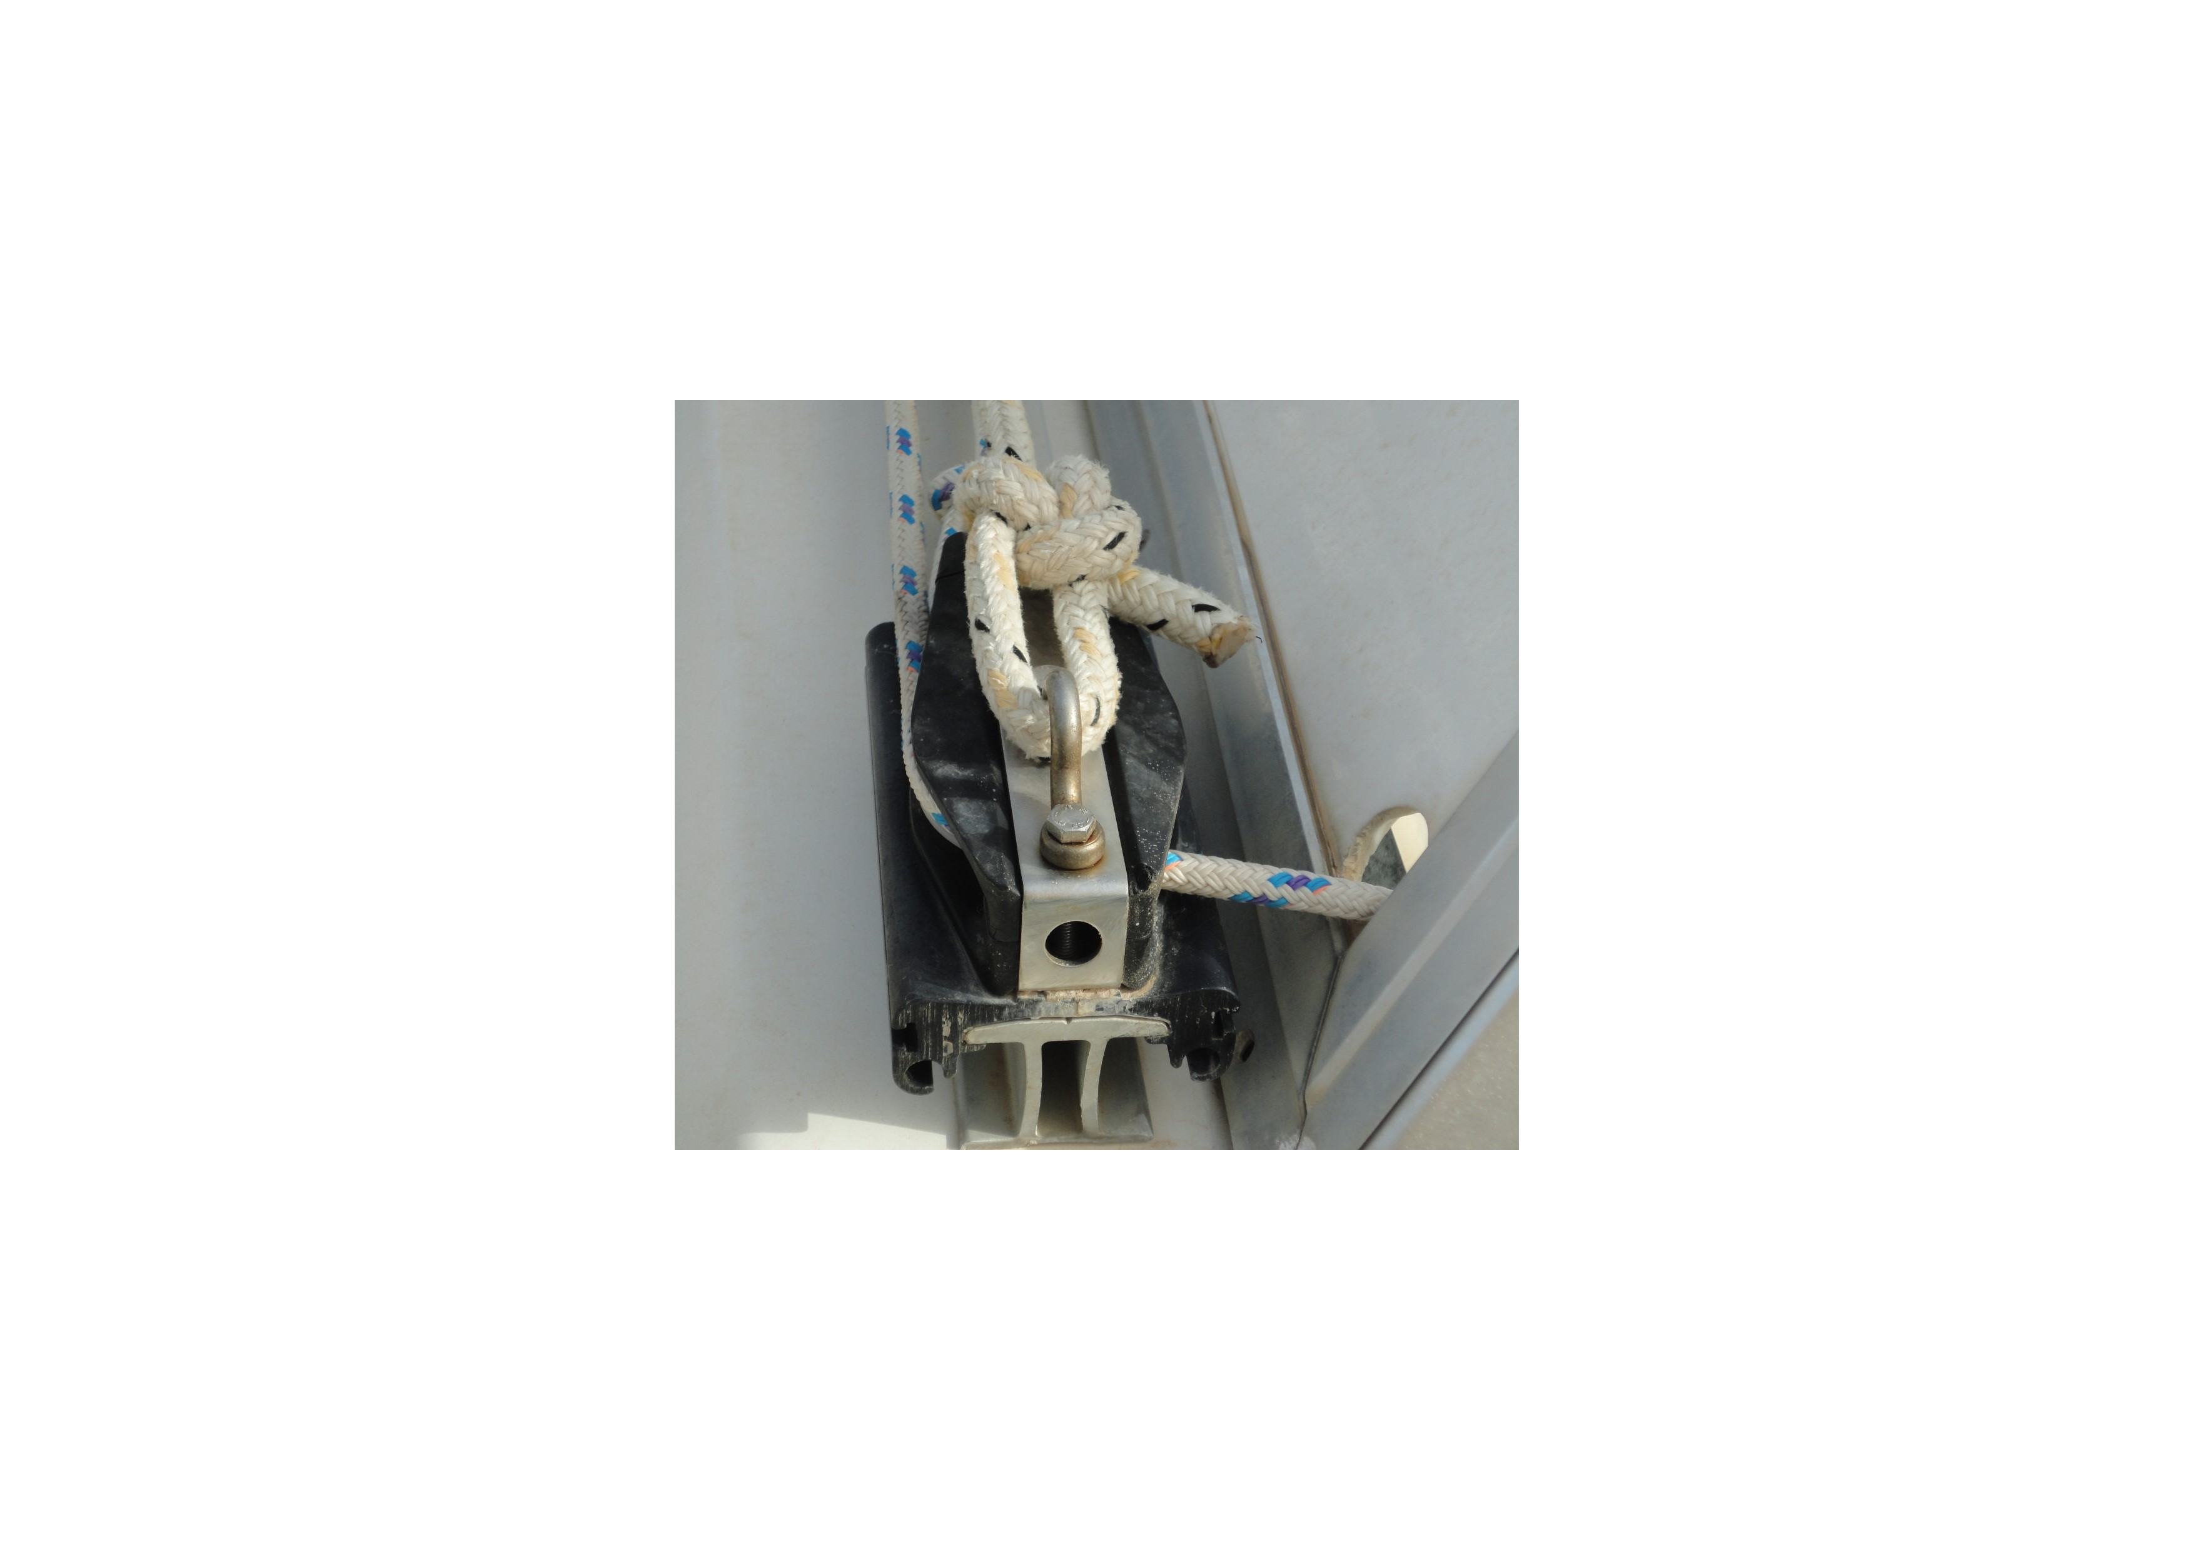

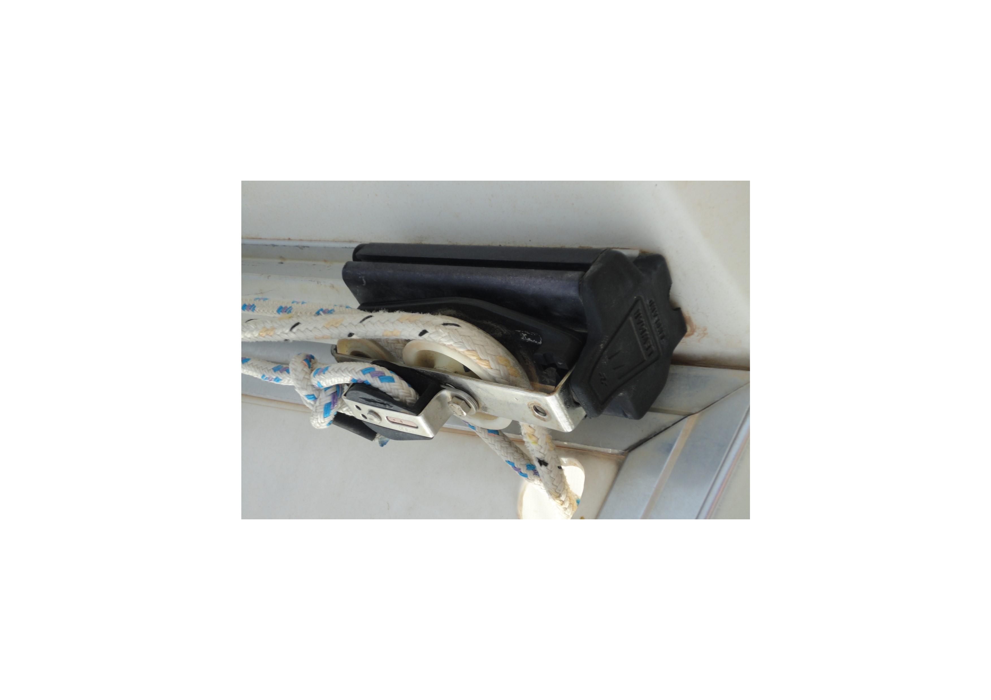

Starboard side end stop. 4.7cm dia pulley for boom tension rope. 3cm dia pulley for traveller outhaul rope and small top pulley (Ref RF900) for traveller return rope. Track overall length 178cm

